**Identifying services**

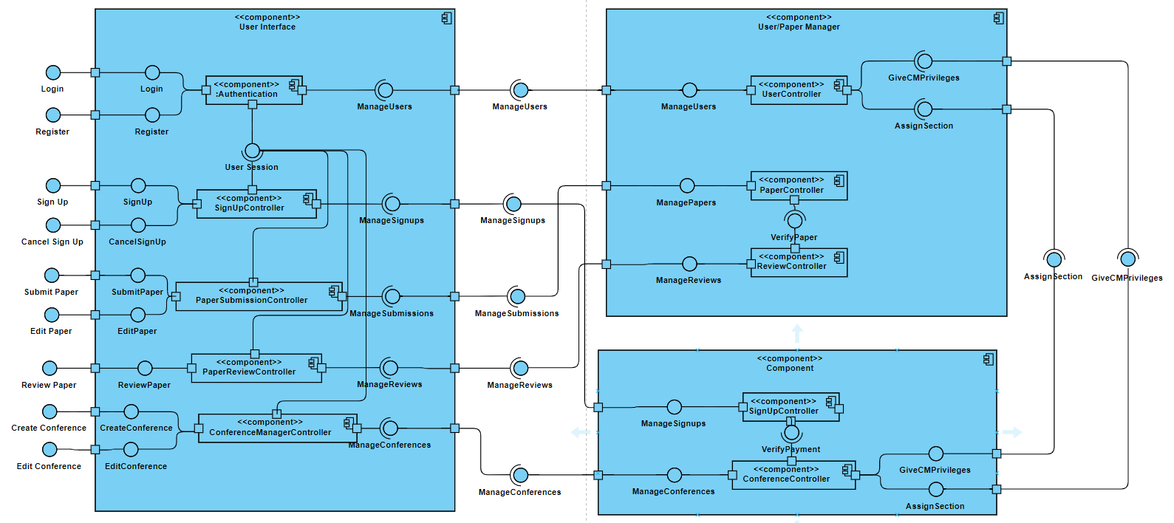

Through the 3 components/subsystems listed above, we can identify the following services available:

User Interface:

Creating a new account (committee/regular account)

Logging in to said account

Signing up/cancelling a sign up for a conference

Submitting/editing a paper

Reviewing a paper for committee members

Creating, editing (changing relevant details) and managing conferences (assigning roles to users, assigning papers to review to committee members), again, for committee members

User/Paper Manager:

Managing users (CRUD operations for user accounts)

Managing papers (CRUD operations for papers, but also propagating CM reviews)

Managing reviews (CRUD operations for reviews)

Conference Manager:

Managing conferences (CRUD operations for conferences, assigning roles to users)

Managing user signups for conferences, verifying their payment and assigning them to sections accordingly